Final LLM Chatbot Design and Reflection Report
Course Project Deliverable
Date: February 20, 2026

1. Problem Context
The project addresses a core weakness of general-purpose chatbots in academic settings: fluent but ungrounded answers. Our goal was to build an LLM chatbot that can answer user questions with stronger reliability by combining grounded retrieval with general LLM answering. The solution supports English user prompts and produces Spanish output, with optional English output for transparency.

2. Scope and Project Objectives
Based on the original proposal, the scope included:
- Build a practical chatbot interface for end users (web chat UI).
- Ground answers in project knowledge sources (proposal, design report, and added KB files).
- Support bilingual interaction with Spanish response emphasis.
- Use citations/source references where possible to improve trust.
- Provide graceful fallback behavior when no answer is found.
The final implementation follows this scope with a FastAPI backend, React frontend, retrieval layer, and optional Azure OpenAI integration for relevance-routed RAG completion, general Q&A, and translation.

3. Design Decisions During Construction
The design choices were organized around maintainability, reliability, and demo-readiness:

3.1 MVC-Inspired Backend Separation
The backend is structured into controllers, services, repositories, and models. This made responsibilities clear: API contracts in controllers/models, orchestration in services, and document indexing/retrieval in repositories.

3.2 Layered Response Strategy
A multi-stage strategy was selected: (1) rule-based response for deterministic intents, (2) corpus retrieval plus relevance scoring, and (3) Azure OpenAI generation via either RAG context or general answering path. This reduced unnecessary LLM calls and improved predictable behavior.

3.3 Dual Retrieval Path
The repository supports semantic retrieval via SentenceTransformer when available and TF-IDF fallback otherwise. This improves portability by allowing the system to function in constrained environments.

3.4 Translation as a Dedicated Service
Translation was separated from core answer generation. This improved modularity and made it easier to handle translation-specific prompts, fallback handling, and future multilingual extension.

3.5 Configuration-Driven Deployment
Environment variables are used for endpoints, keys, model deployment, API version, CORS, and knowledge base paths. This avoided hardcoded secrets and simplified deployment across local and cloud environments.

4. Screenshots and Visual Evidence
The following captures summarize the implemented UI flow, API behavior, and architecture used for this final submission.
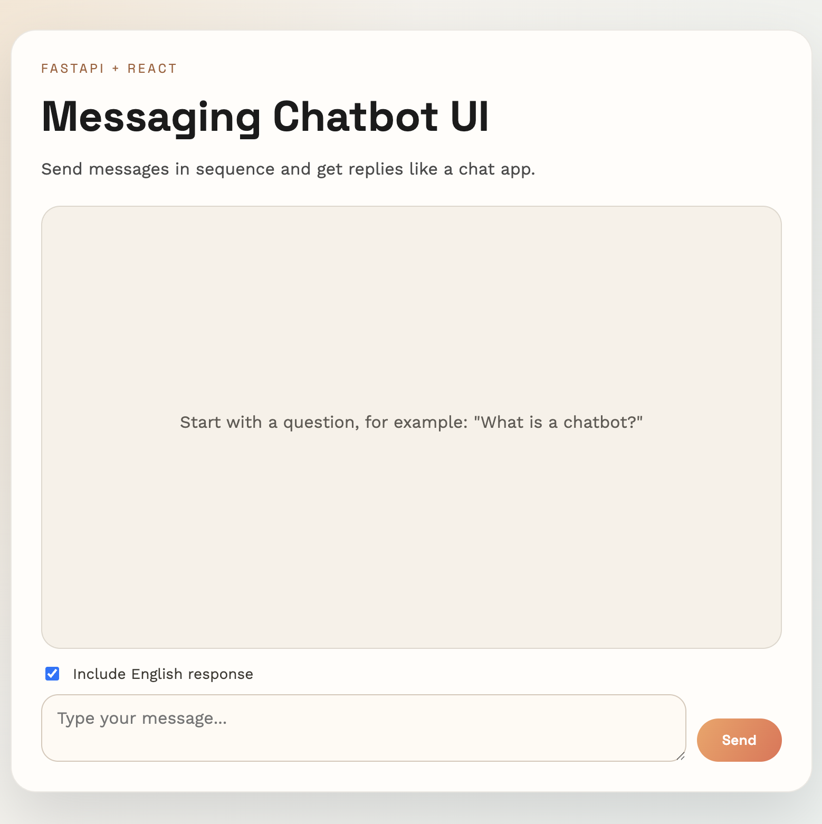
Figure 1: Chatbot UI
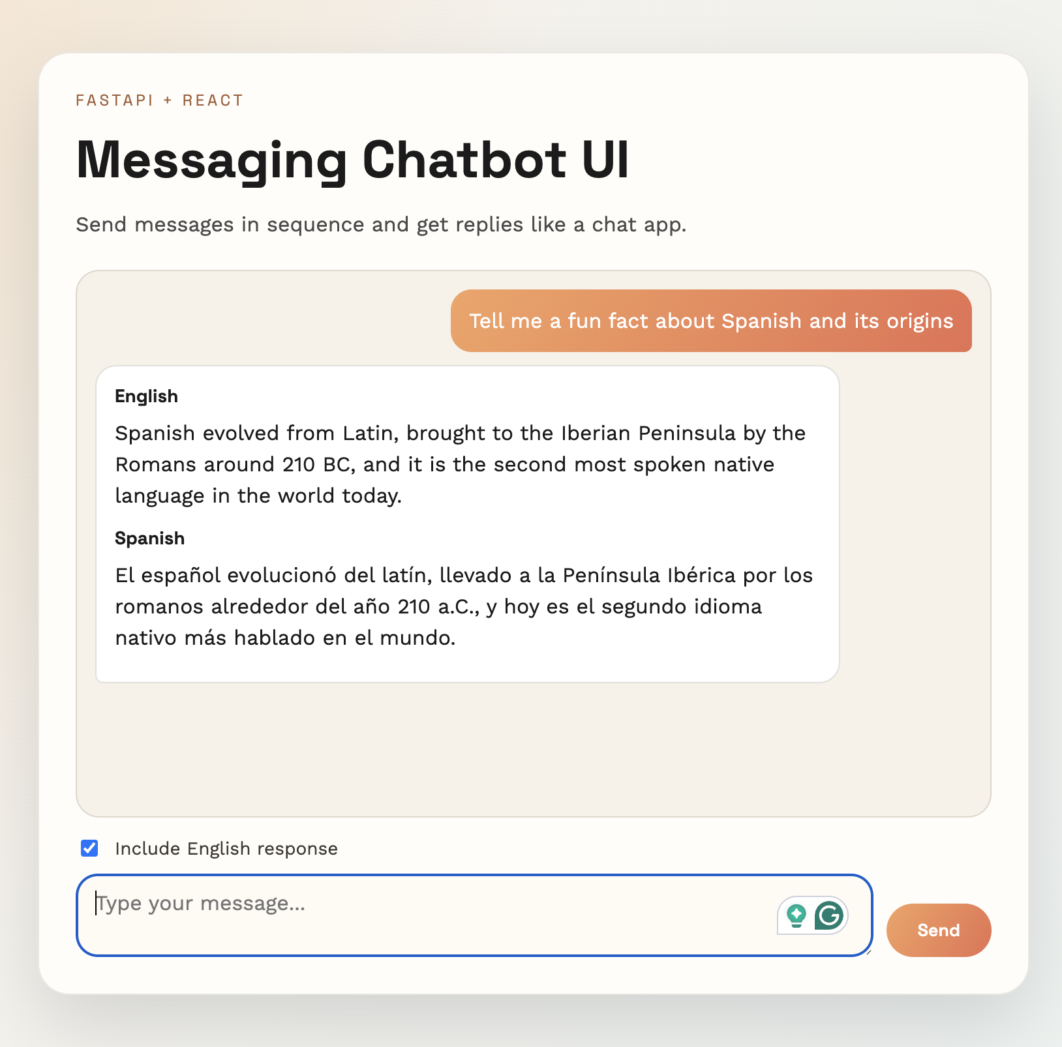
Figure 2: Messaging UI flow with sequential user and LLM based replies messages.
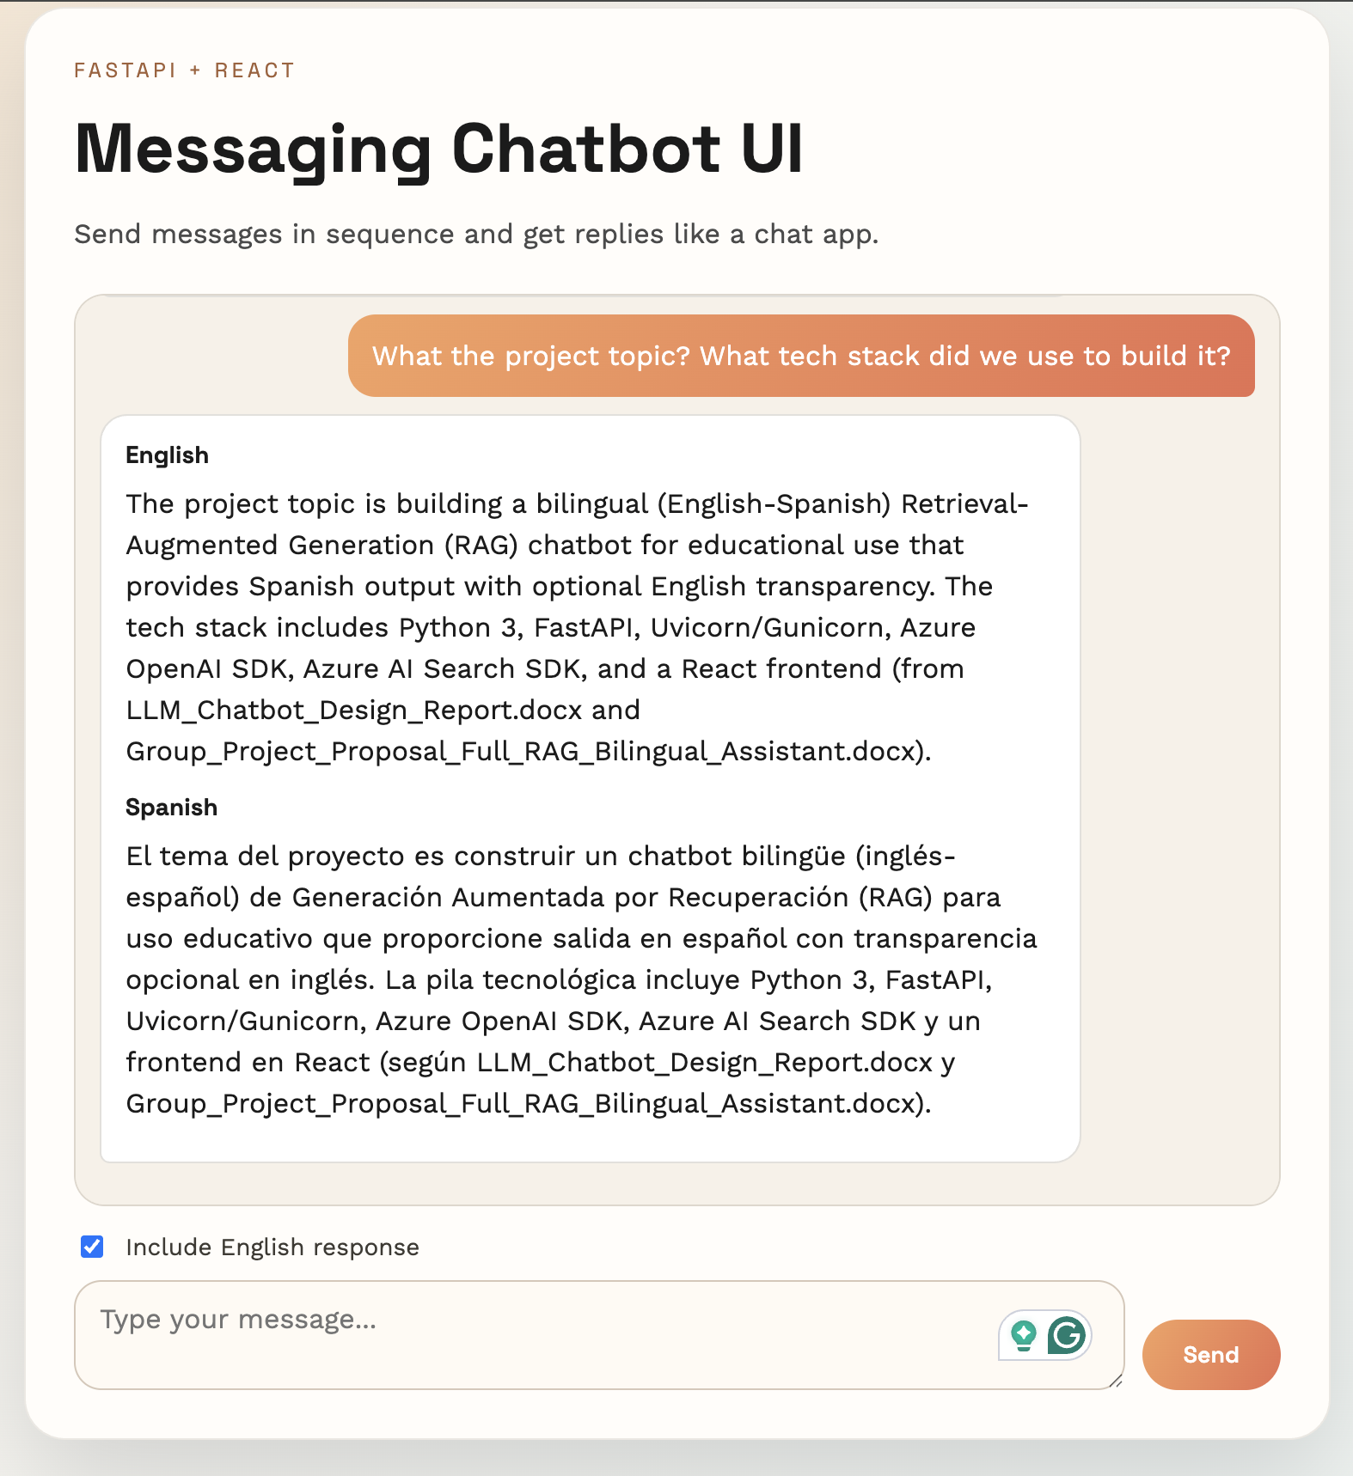
Figure 3: Messaging UI flow with sequential user and RAG based replies messages.
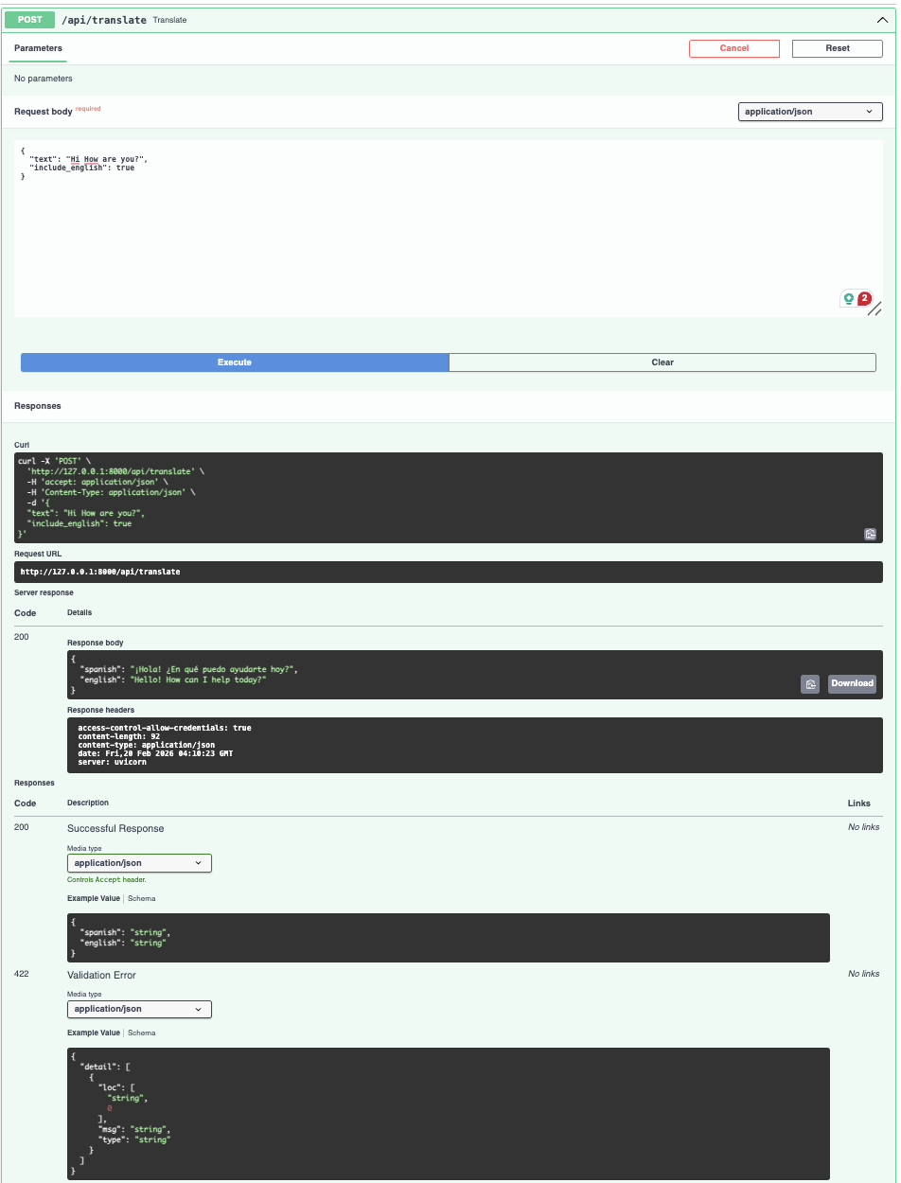
Figure 4: Example API input/output structure including English and Spanish response fields.

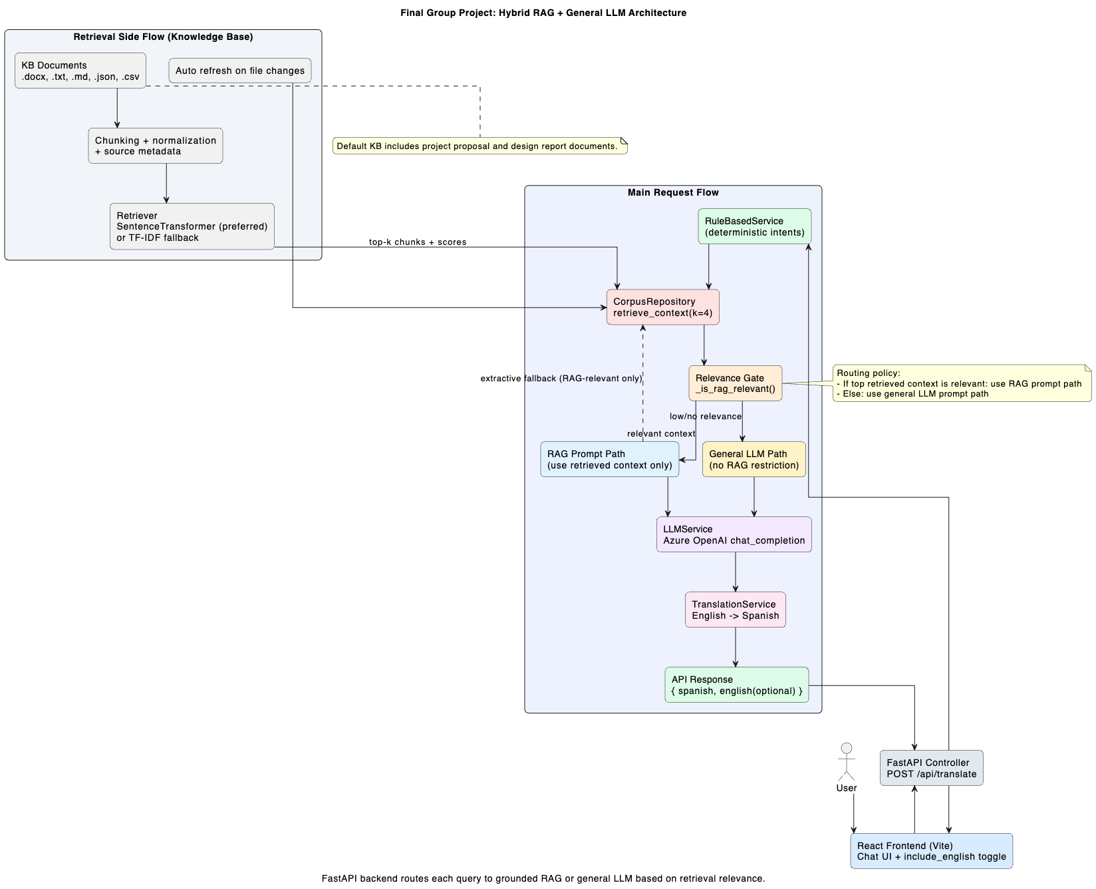
Figure 5: Architecture Diagram

5. Approach Taken (Proposal to Implementation)
The proposal planned a RAG-enabled bilingual assistant with source-grounded responses. During implementation, we preserved that direction while making pragmatic decisions for reliability. Instead of relying only on cloud generation, we introduced rule-based handling plus retrieval relevance routing: use RAG for in-domain questions and general LLM responses for out-of-domain questions. This made the chatbot usable even when cloud features were unavailable. The React chat interface was selected over one-shot forms to better match conversational HCI expectations.

6. Challenges Encountered
- Dependency and environment constraints: optional ML and cloud libraries are not always available in every run environment.
- Retrieval quality tuning: selecting chunk sizes and similarity thresholds required iterative calibration to avoid irrelevant matches.
- Bilingual quality consistency: preserving concise meaning across English generation and Spanish translation needed prompt and temperature tuning.
- Knowledge coverage gaps: when the question is outside indexed content, the system must avoid forced RAG behavior and route safely to general answering.
- Balancing cost, latency, and quality: cloud LLM calls were limited to cases where deterministic/local strategies were insufficient.

7. Key Learnings
- Hybrid chatbot architectures are more reliable than LLM-only patterns for coursework and domain-limited assistants.
- A clear service/repository separation significantly improves debugging and future extension.
- RAG performance depends as much on chunking and retrieval thresholds as on the model itself.
- Graceful degradation is essential; users should receive stable, understandable responses even under partial outages.
- UI continuity (chat thread + loading states) materially improves user trust and usability perception.

8. Conclusion
The final chatbot satisfies the core project intent: a bilingual assistant built with maintainable architecture and practical reliability controls. It now supports both grounded RAG answers and general LLM Q&A through relevance-based routing, while preserving bilingual output behavior. The project demonstrates integration of traditional NLP logic with modern LLM/RAG methods and provides a strong baseline for future enhancements such as persistent session memory, stronger evaluation metrics, and expanded multilingual support.

9. References to Project Artifacts
- Group_Project_Proposal_Full_RAG_Bilingual_Assistant.docx (Proposal, January 31, 2026)
- LLM_Chatbot_Design_Report.docx (Design report, February 19, 2026)
- backend/app/* (FastAPI MVC-style implementation)
- frontend/src/App.jsx (Messaging UI implementation)

